Screenshot.png assignment Screenshot 1.png includes visual proof that remote assistance is turned off to prevent unwanted people having access to your computer remotely. The Screenshot 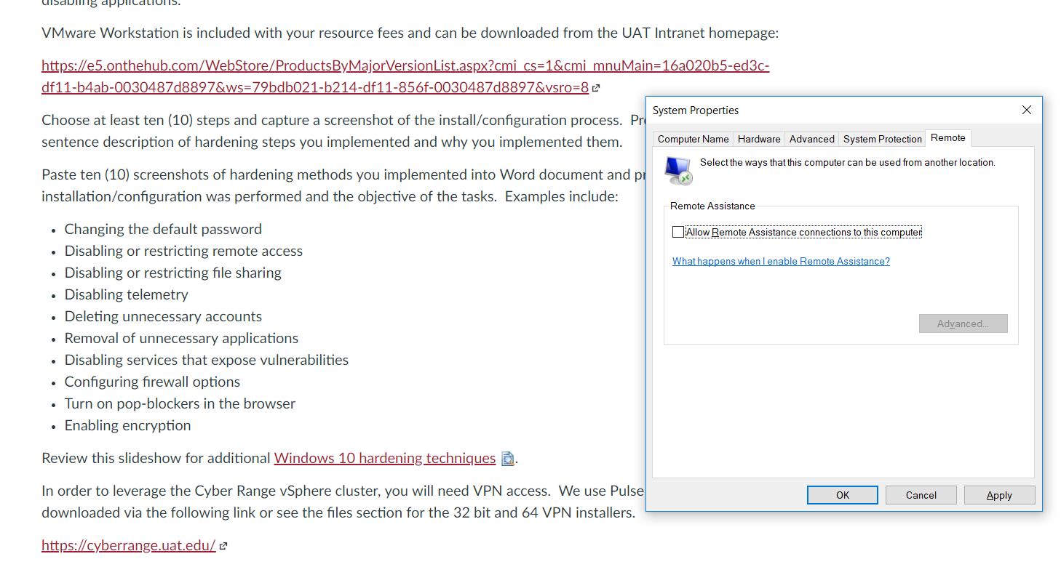

2.png includes me checking my advanced sharing settings as to make sure network discovery is turned off for security reasons. 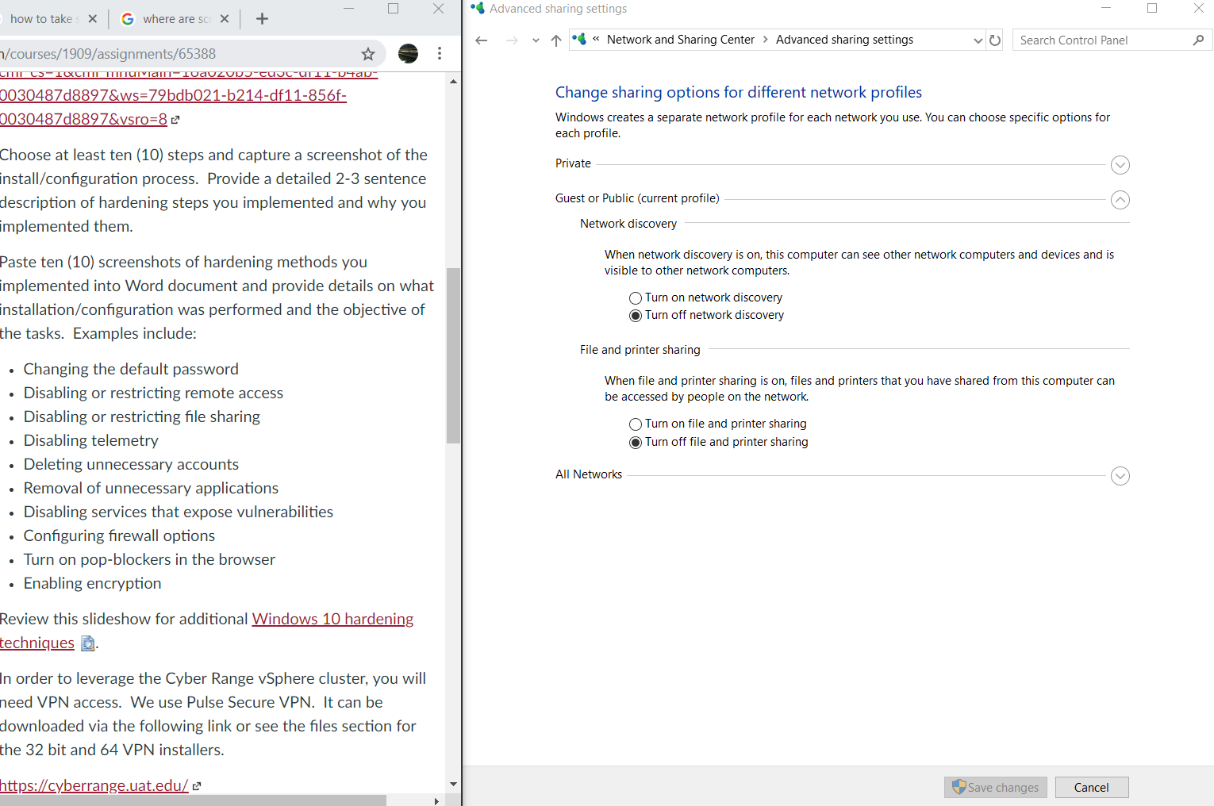

Screenshot 3.png shows that office telemetry log is not enabled yet as to prevent possibly security compromise. 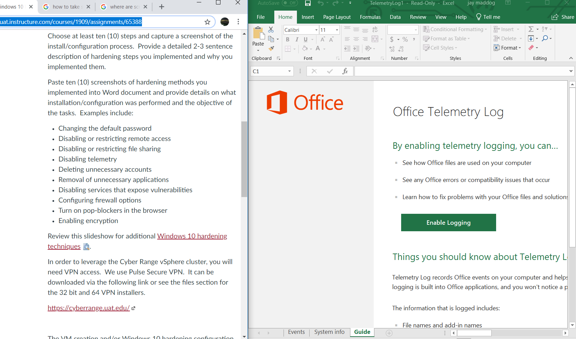

Screenshot 4 shows the users currently available on the computer and is a good way to check if any guest accounts exist as guest accounts can be a security risk. 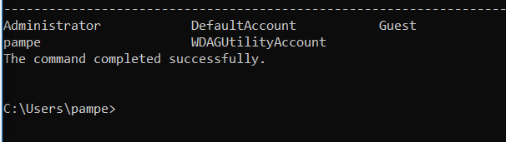

Screenshot 5 is a picture of the inbound and outbound rules in the firewall which have been looked over by me to make sure there is no causes for alarm in the rules listed. 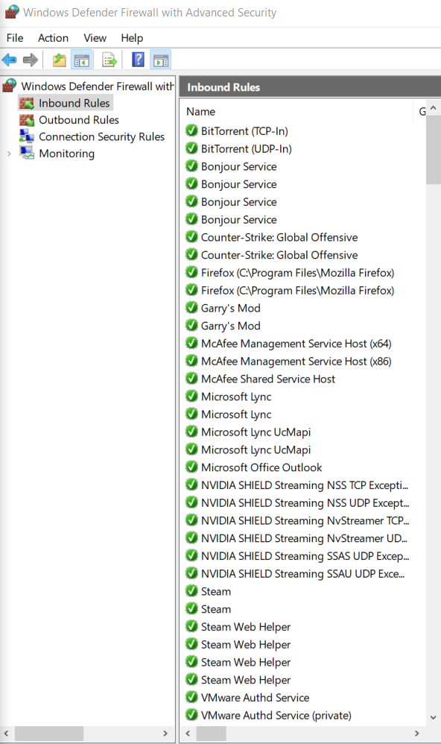

Screenshot 6 shows my use of ublock origin to prevent pop ups and adds to further prevent possibility of clicking on adds or getting other possibly fishy stuff meant to harm your pc.

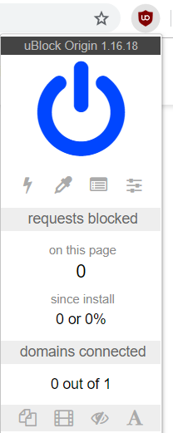

Screenshot 7 shows my privacy settings on my other firefox browser that includes blocking of pop ups and is one step of securing a firefox browser. 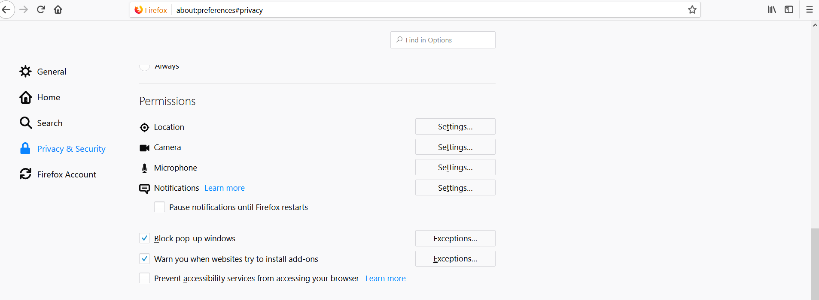

Screenshot 8 shows that cortana is turned off and prevents listening of device as to further reduce risk of spyware. 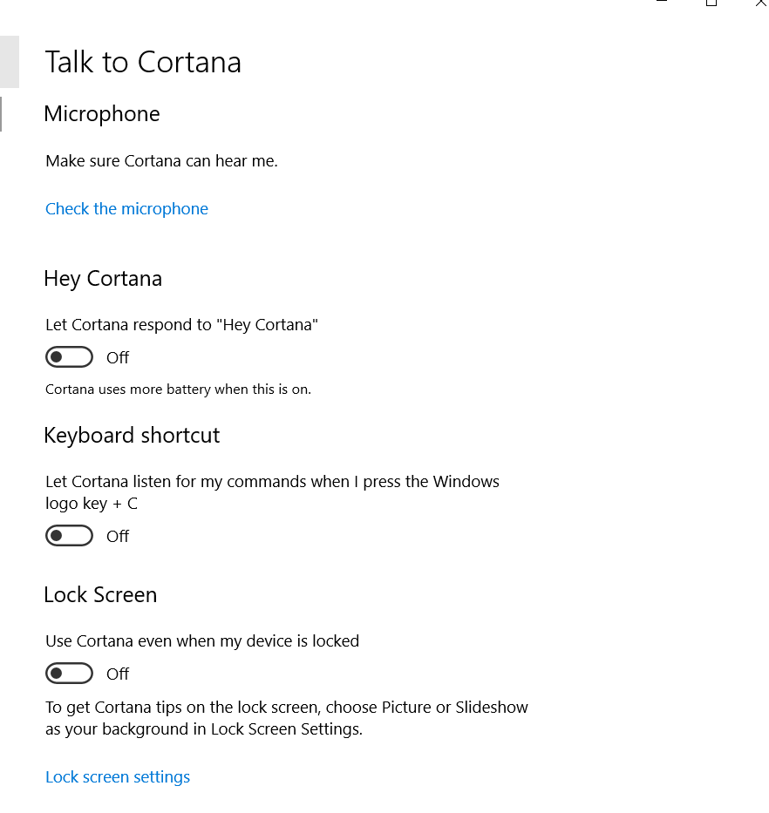

Screenshot 9 includes a picture of veracrypt as it was used to encrypt my drive for further drive security. 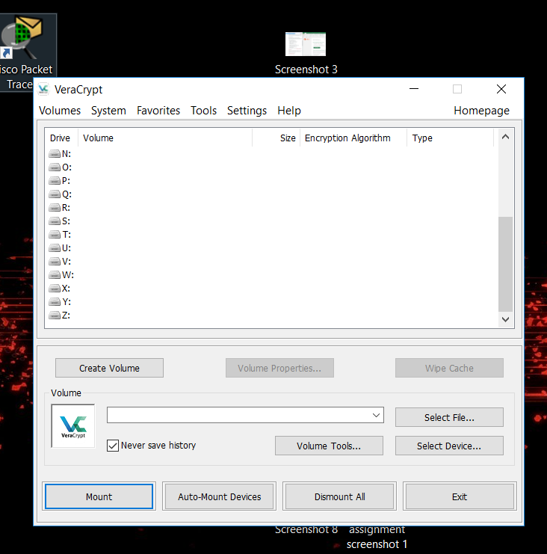Thanks for your time -Andrew M